1/3/2026 1:35:40 PM

NAME: BILKISU MUHAMMAD | Age:Ad | Sex:F
Clinical Details: USG Pelvic

REAL TIME ABDOMINOPELVIC ULTRASONOGRAPHY EXAM: REVEALED:

LIVER:Normal in size and uniform homogenous echotexure seen. No surface retraction or nodulations. No definite focal lesion. Intrahepatic biliary radicles are not dilated. Hepatic veins and I.V.C are not congested. Portal vein is not dilated.

GALL BLADDER:Semi-contacted at time of examination: however no sizable intra-luminal stone seen. C.B.D is seen patent and not dilated. Wall thickness normal

PANCREAS:Normal in size with normal parenchymal echoes. MPD not dilated. No gross masses detected

SPLEEN:Normal in size with normal echo pattern. No focal lesion seen
BOTH KIDNEYS:Average size with normal shape and smooth outline. Normal parenchymal Echogenicity with good CMD. No backpressure changes cystic or sizable typical calculi seen.

URINARY BLADDER:Distended with urine with normal mucosal thickness. No gross masses or stone seen.
UTERUS: Anteverted and measures 50mm in widest AP dimension with the cavity containing mild anechoic free fluid ?hematometra. Myometrialechoes are preserved. Right and Left adnexea are free.

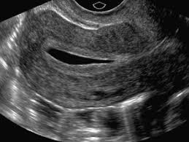
IMPRESSION:Features are suggestive of Mild Hematometra.

Ultrasound specialist.

